|  |  |
| --- | --- |
| KSU_logo.jpg | **King Saud University**  **College of Computer and Information Sciences**  **Department of Computer Science** |

**CSC 220: Computer Organization**

**Labwork - #4**

**Name: Saud Amer alkahtani,id:436102946,day:Sunday,Hour:4to6pm**

1. **Introduction**

In this lab , we find the benefit of “don’t care inputs” and how we can get it to help us.

1. **Experiments**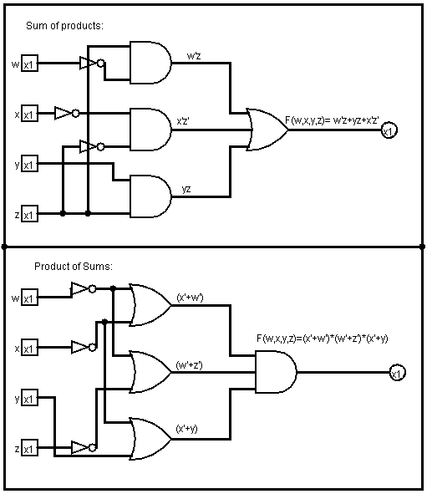
2. **Results**

Sum of products:

F(w,x,y,z)=∑(0.1.2.3,7,8,10)

d(w,x,y,z)=∑(5,6,11,15)

|  |  |  |  |  |
| --- | --- | --- | --- | --- |
| wx yz | 00 | 01 | 11 | 10 |
| 00 | 1 | 1 | 1 | 1 |
| 01 |  | x | 1 | X |
| 11 |  |  | x |  |
| 10 | 1 |  | x | 1 |

|  |  |  |  |  |
| --- | --- | --- | --- | --- |
| wx yz | 00 | 01 | 11 | 10 |
| 00 | 1 | 1 | 1 | 1 |
| 01 |  | x | 1 | x |
| 11 |  |  | x |  |
| 10 | 1 |  | x | 1 |

F(w,x,y,z)= w’z+yz+x’z’

-------------------------------------------------------------------------------------------

Product of sum:

F(w,x,y,z)=∑(4,9,12,13,14)

D(w,x,y,z)=∑(5,6,11,15)

|  |  |  |  |  |
| --- | --- | --- | --- | --- |
| wx yz | 00 | 01 | 11 | 10 |
| 00 |  |  |  |  |
| 01 | 0 | x |  | x |
| 11 | 0 | 0 | x | 0 |
| 10 |  | 0 | x |  |

|  |  |  |  |  |
| --- | --- | --- | --- | --- |
| wx yz | 00 | 01 | 11 | 10 |
| 00 |  |  |  |  |
| 01 | 0 | x |  | x |
| 11 | 0 | 0 | x | 0 |
| 10 |  | 0 | x |  |

F(w,x,y,z)=(x’+y)\*(w’+z’)\*(w’+x’)

1. **Discussion**

We found in this lab that using a don’t care input can help us in reducing costs and make our logic circuits compact.